ES18 Solution Sketch

1. Draw the elevation view of the basin

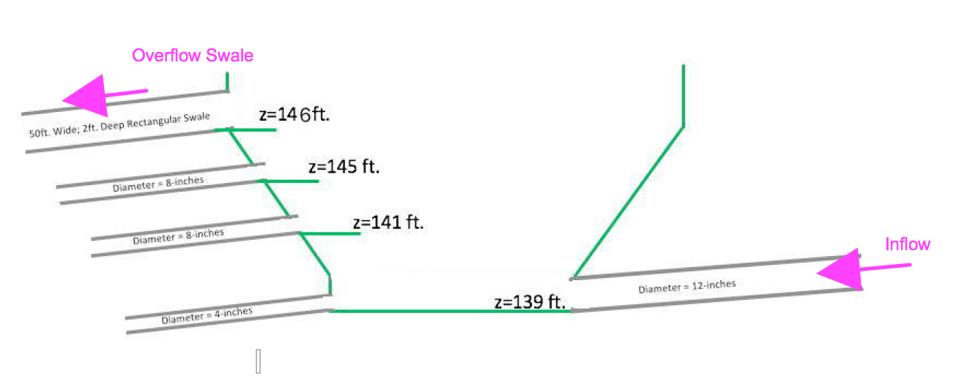

Figure 1. Elevation view of basin and outlet works.

1. Capture Image into a PDF

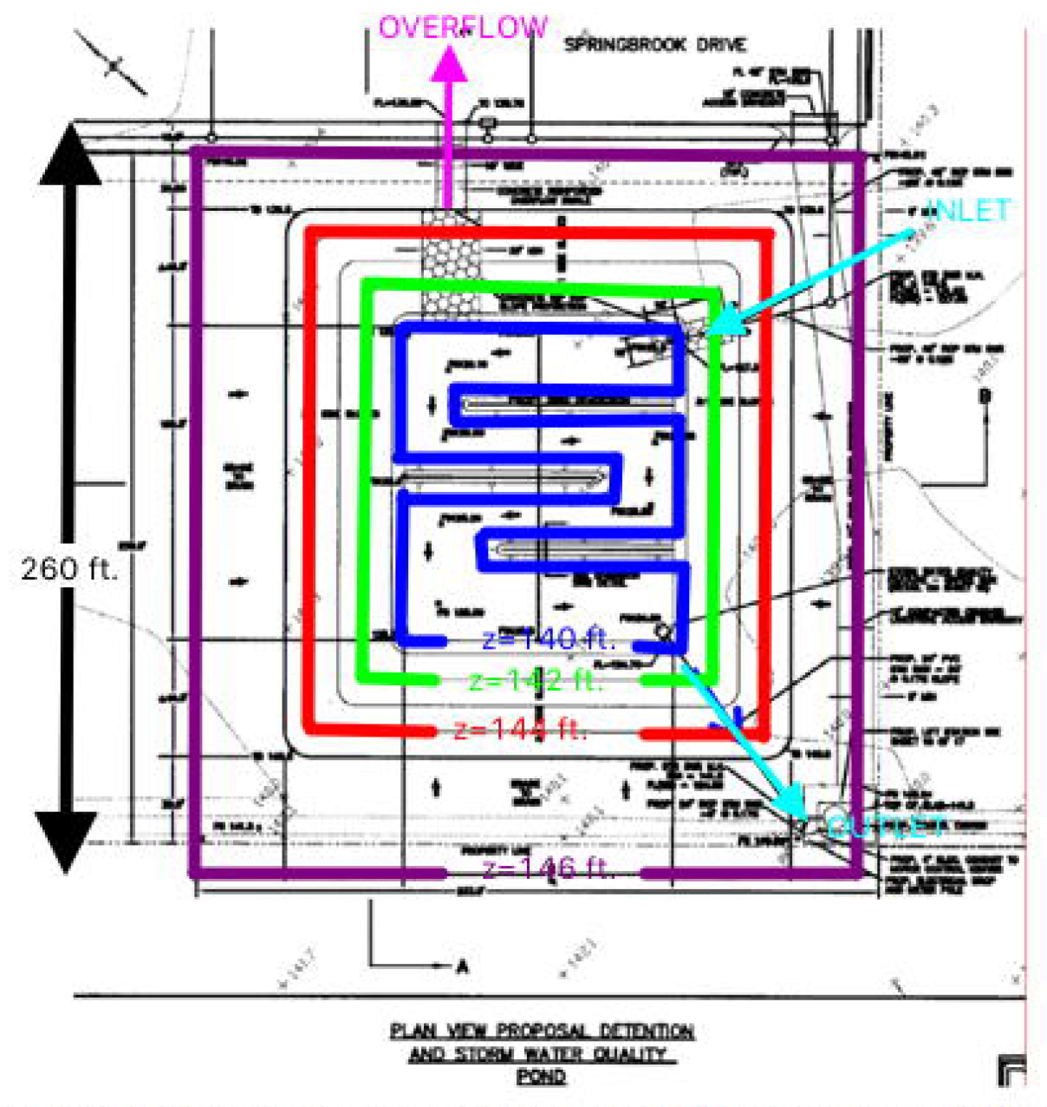

1. Use Measurement Tools to Find Area of Big Square

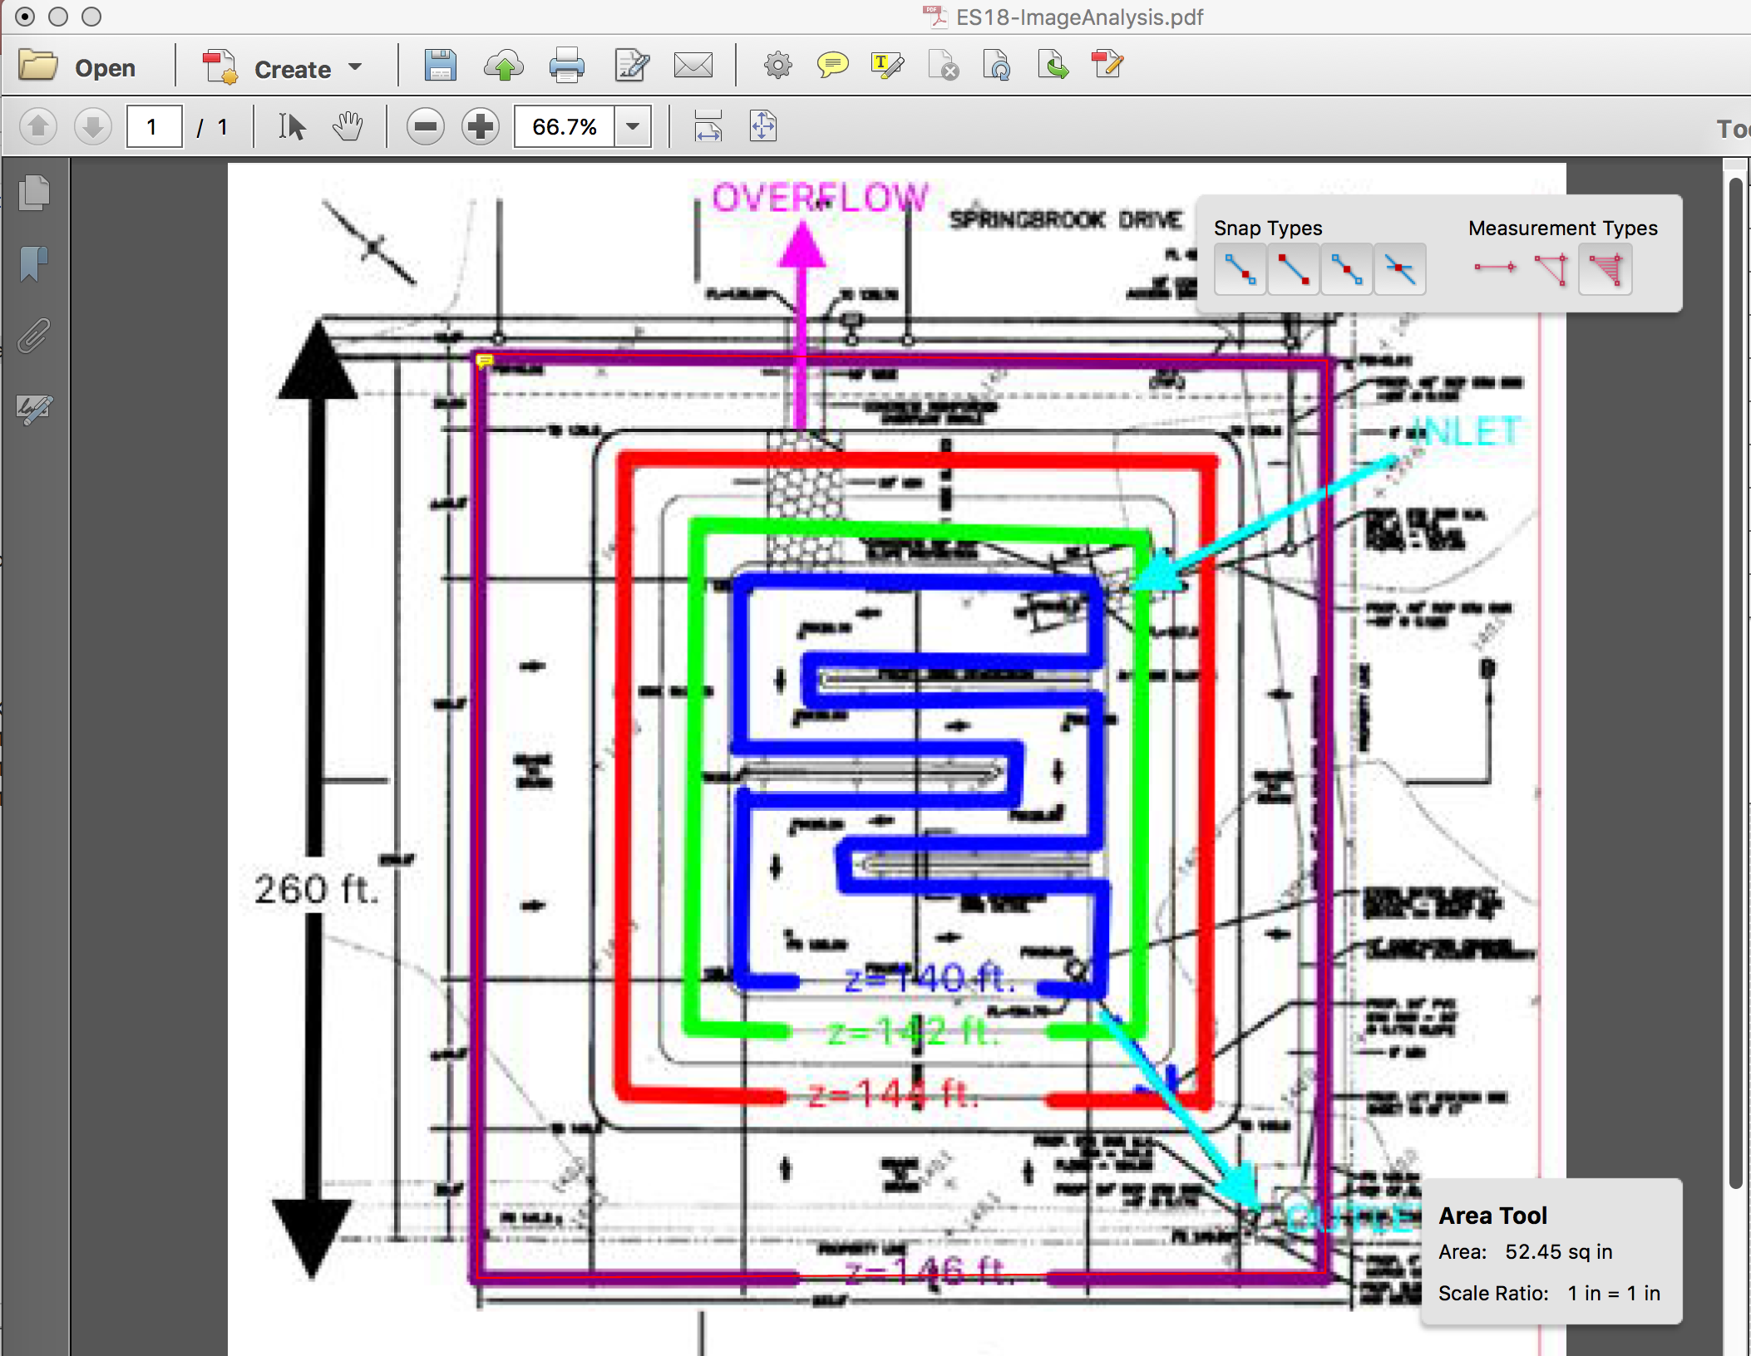

Figure 2. Area Measure for 146 ft Contour

The big square is 260X260 feet which is equal to 52.45 sq.in. on the PDF image. Thus: 52.45 sq.in. = 67,600 ft^2 = 1.55 acres. The conversion to use for a generic measurement is: 1 sq.in. = 1288.8 ft^2

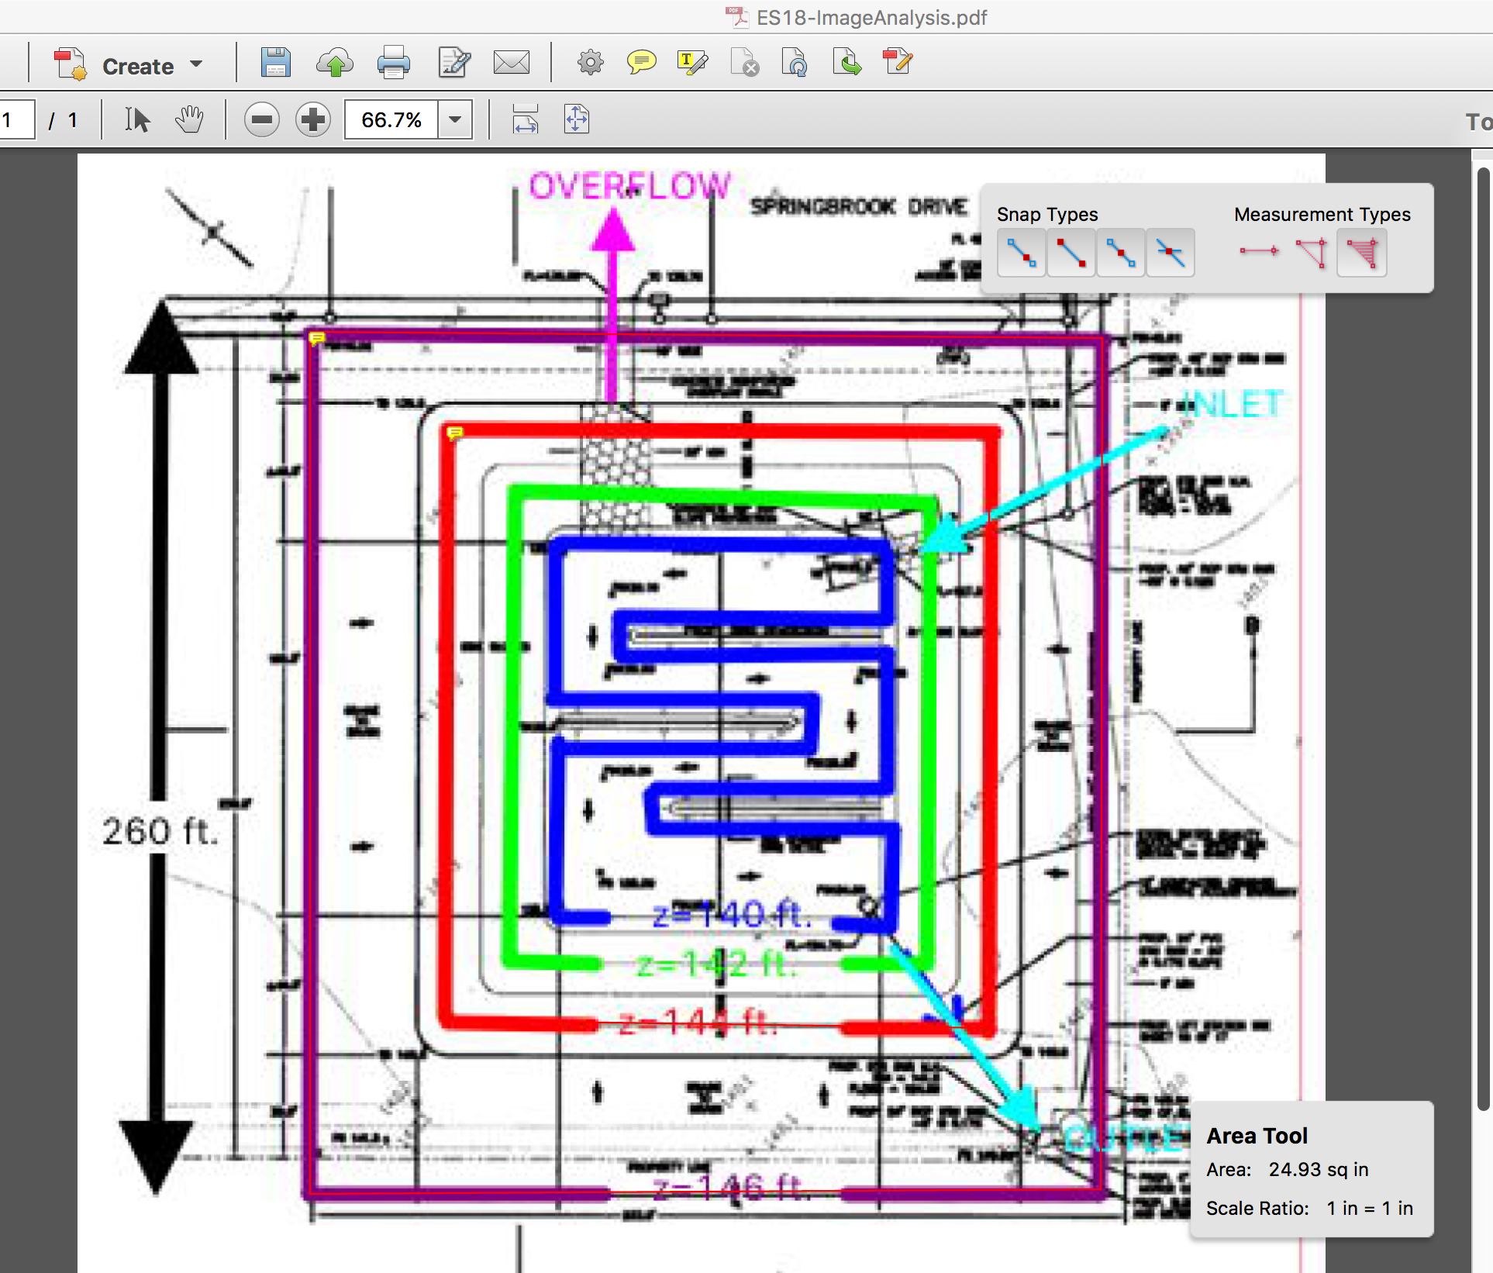

Figure 3. Area measure 145 ft. contour

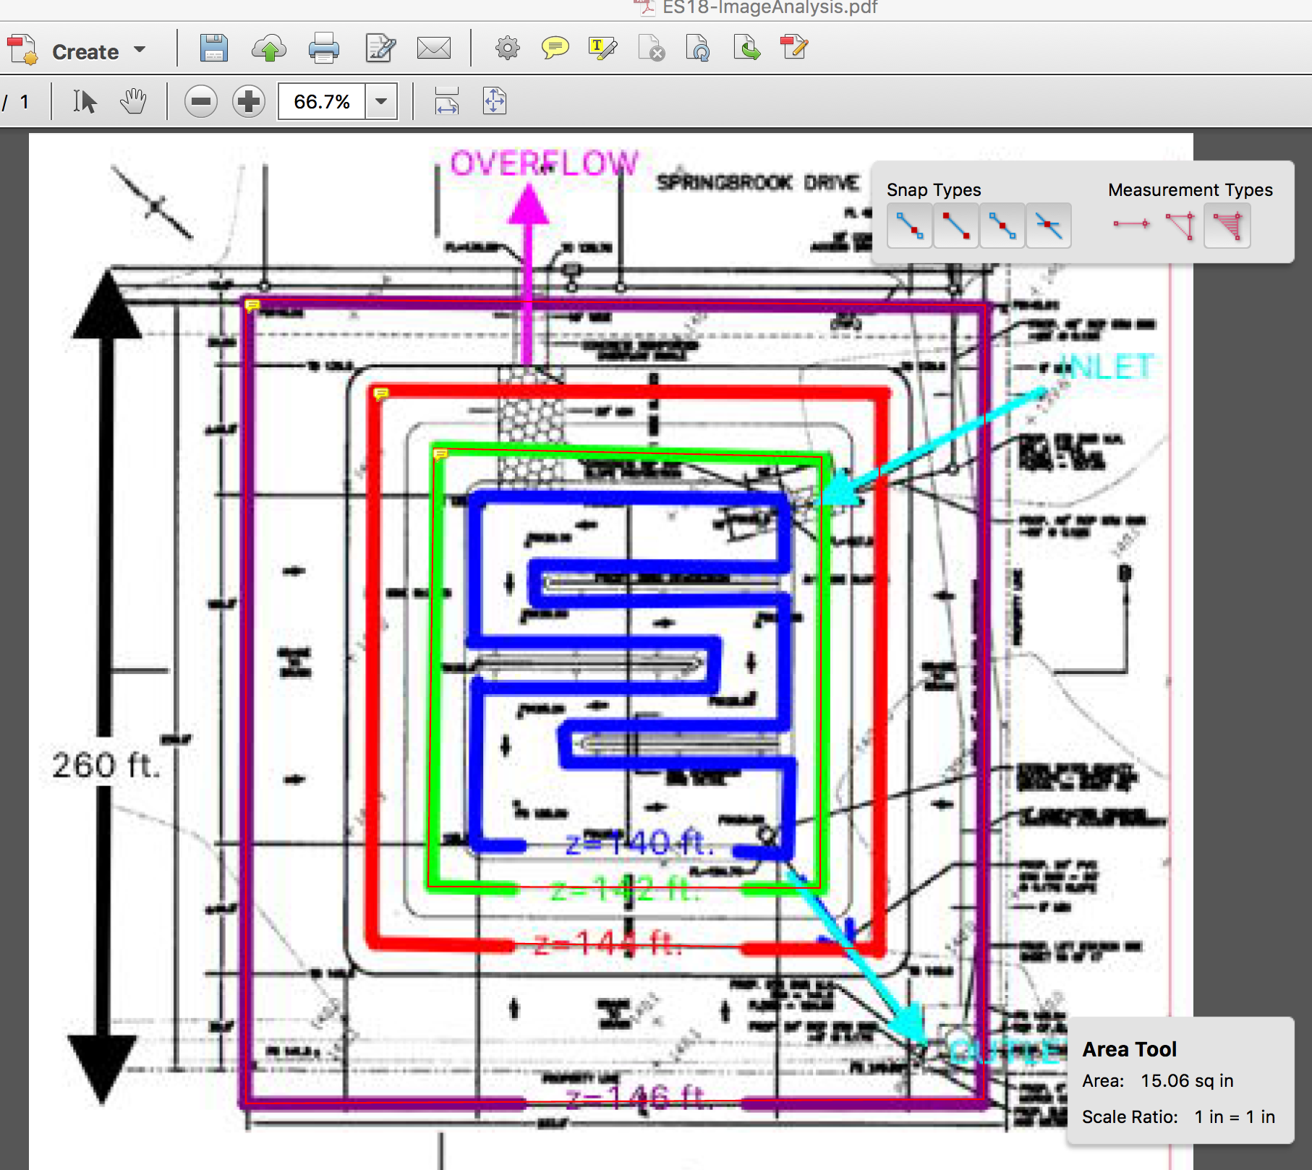

Figure 4. Area Measure 142 ft. contour

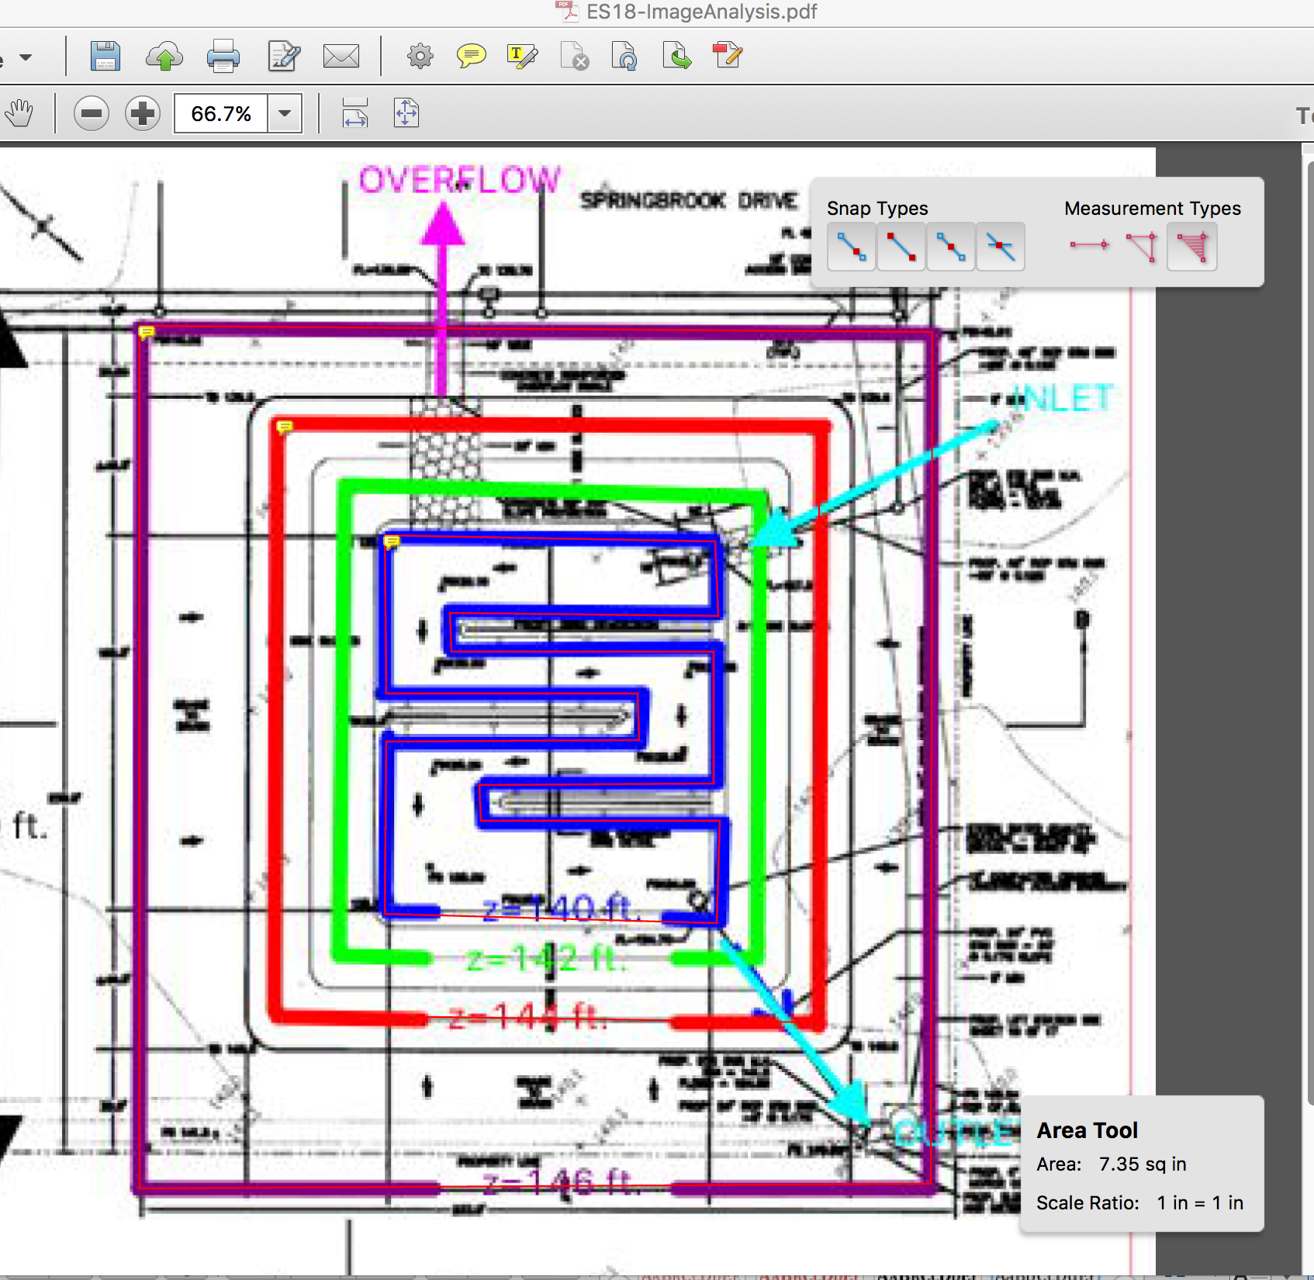

Figure 5. Area Measure 140 ft. contour

1. Build a Conversion Table

|  |  |  |  |  |
| --- | --- | --- | --- | --- |
| Contour | Depth | PDF Area | Area FT^2 | Area Acres |
| 147 | 8 ft | 52.45 | 67,600 | 1.552 |
| 146 | 7 ft | 52.45 | 67,600 | 1.552 |
| 144 | 5 ft | 24.93 | 32,130 | 0.737 |
| 142 | 3 ft | 15.06 | 19,410 | 0.445 |
| 140 | 1 ft | 7.35 | 9,743 | 0.223 |
| 139 | 0ft | 0ft | 0 | 0 |

1. Now Build the SWMM model  
   The different outlets from the pond are labeled. The collector node form the watershed is a 9-acre storage unit to reflect watershed collected depth.

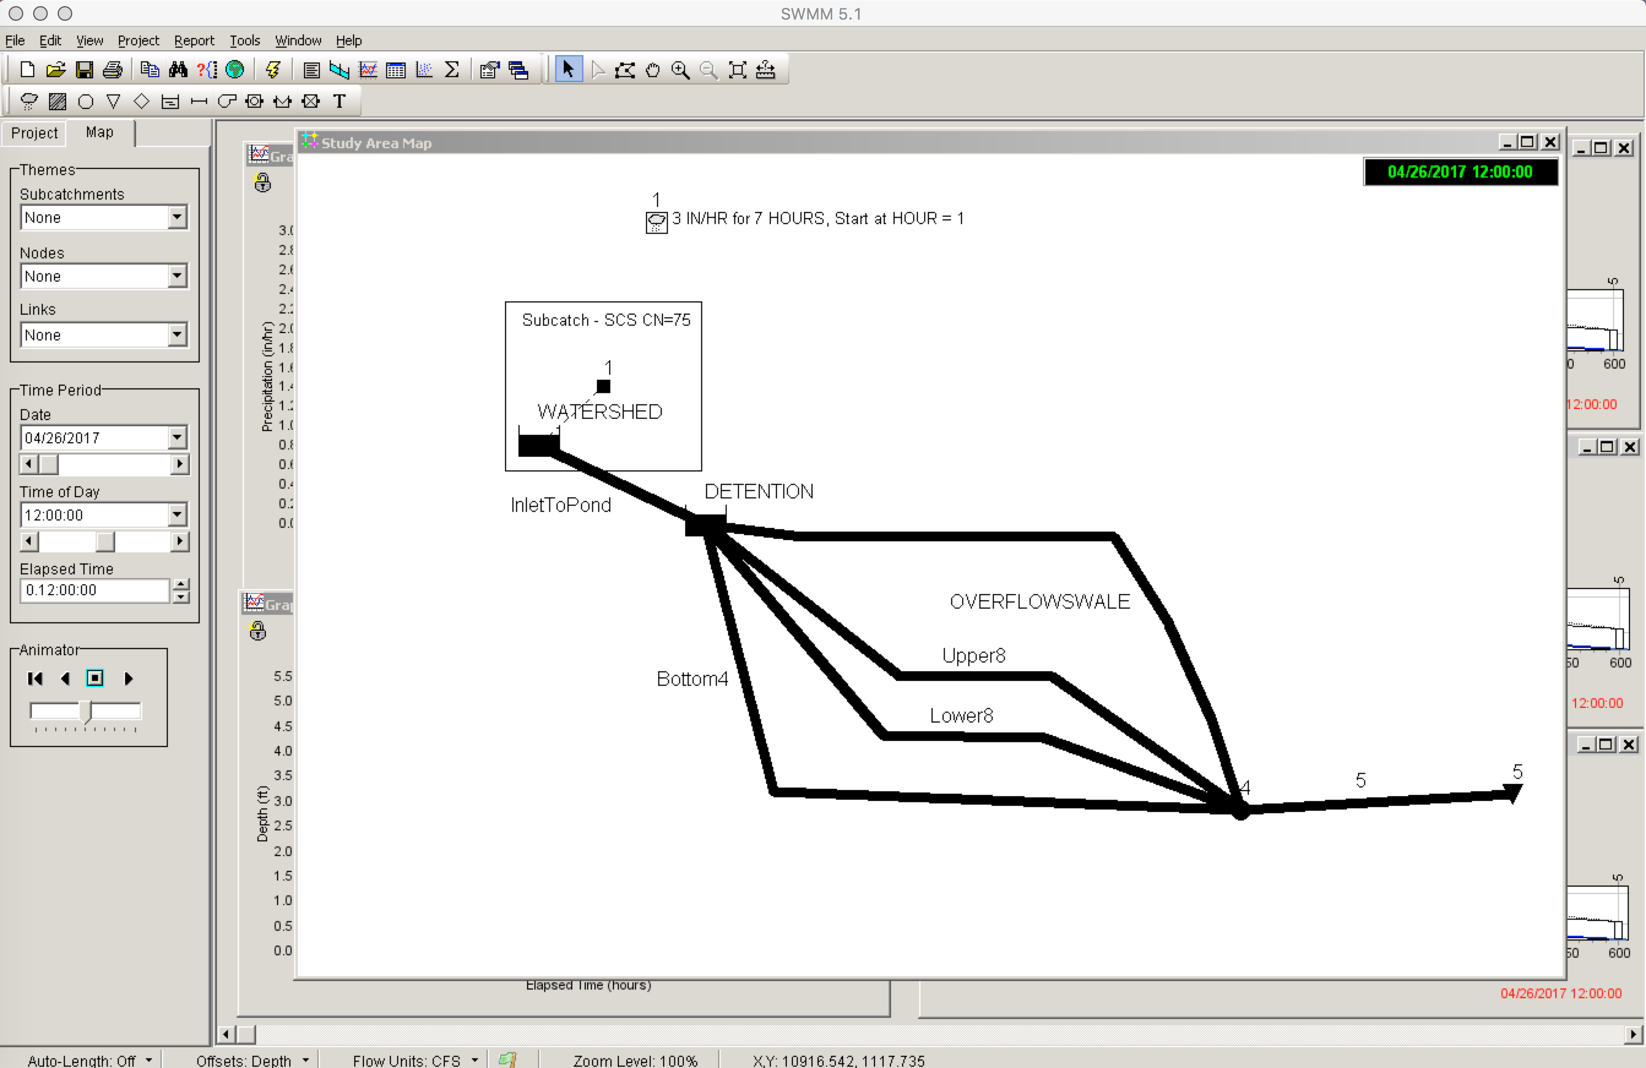

Figure 6. SWMM Model Layout -- Multi-Level Drains

1. Results using problem supplied values. The graphs show that the HGL is contained in the two lower outlet pipes. There is considerable storage in the basin (as well as on the watershed) – the upper two outlets in the basin do not activate under supplied conditions.

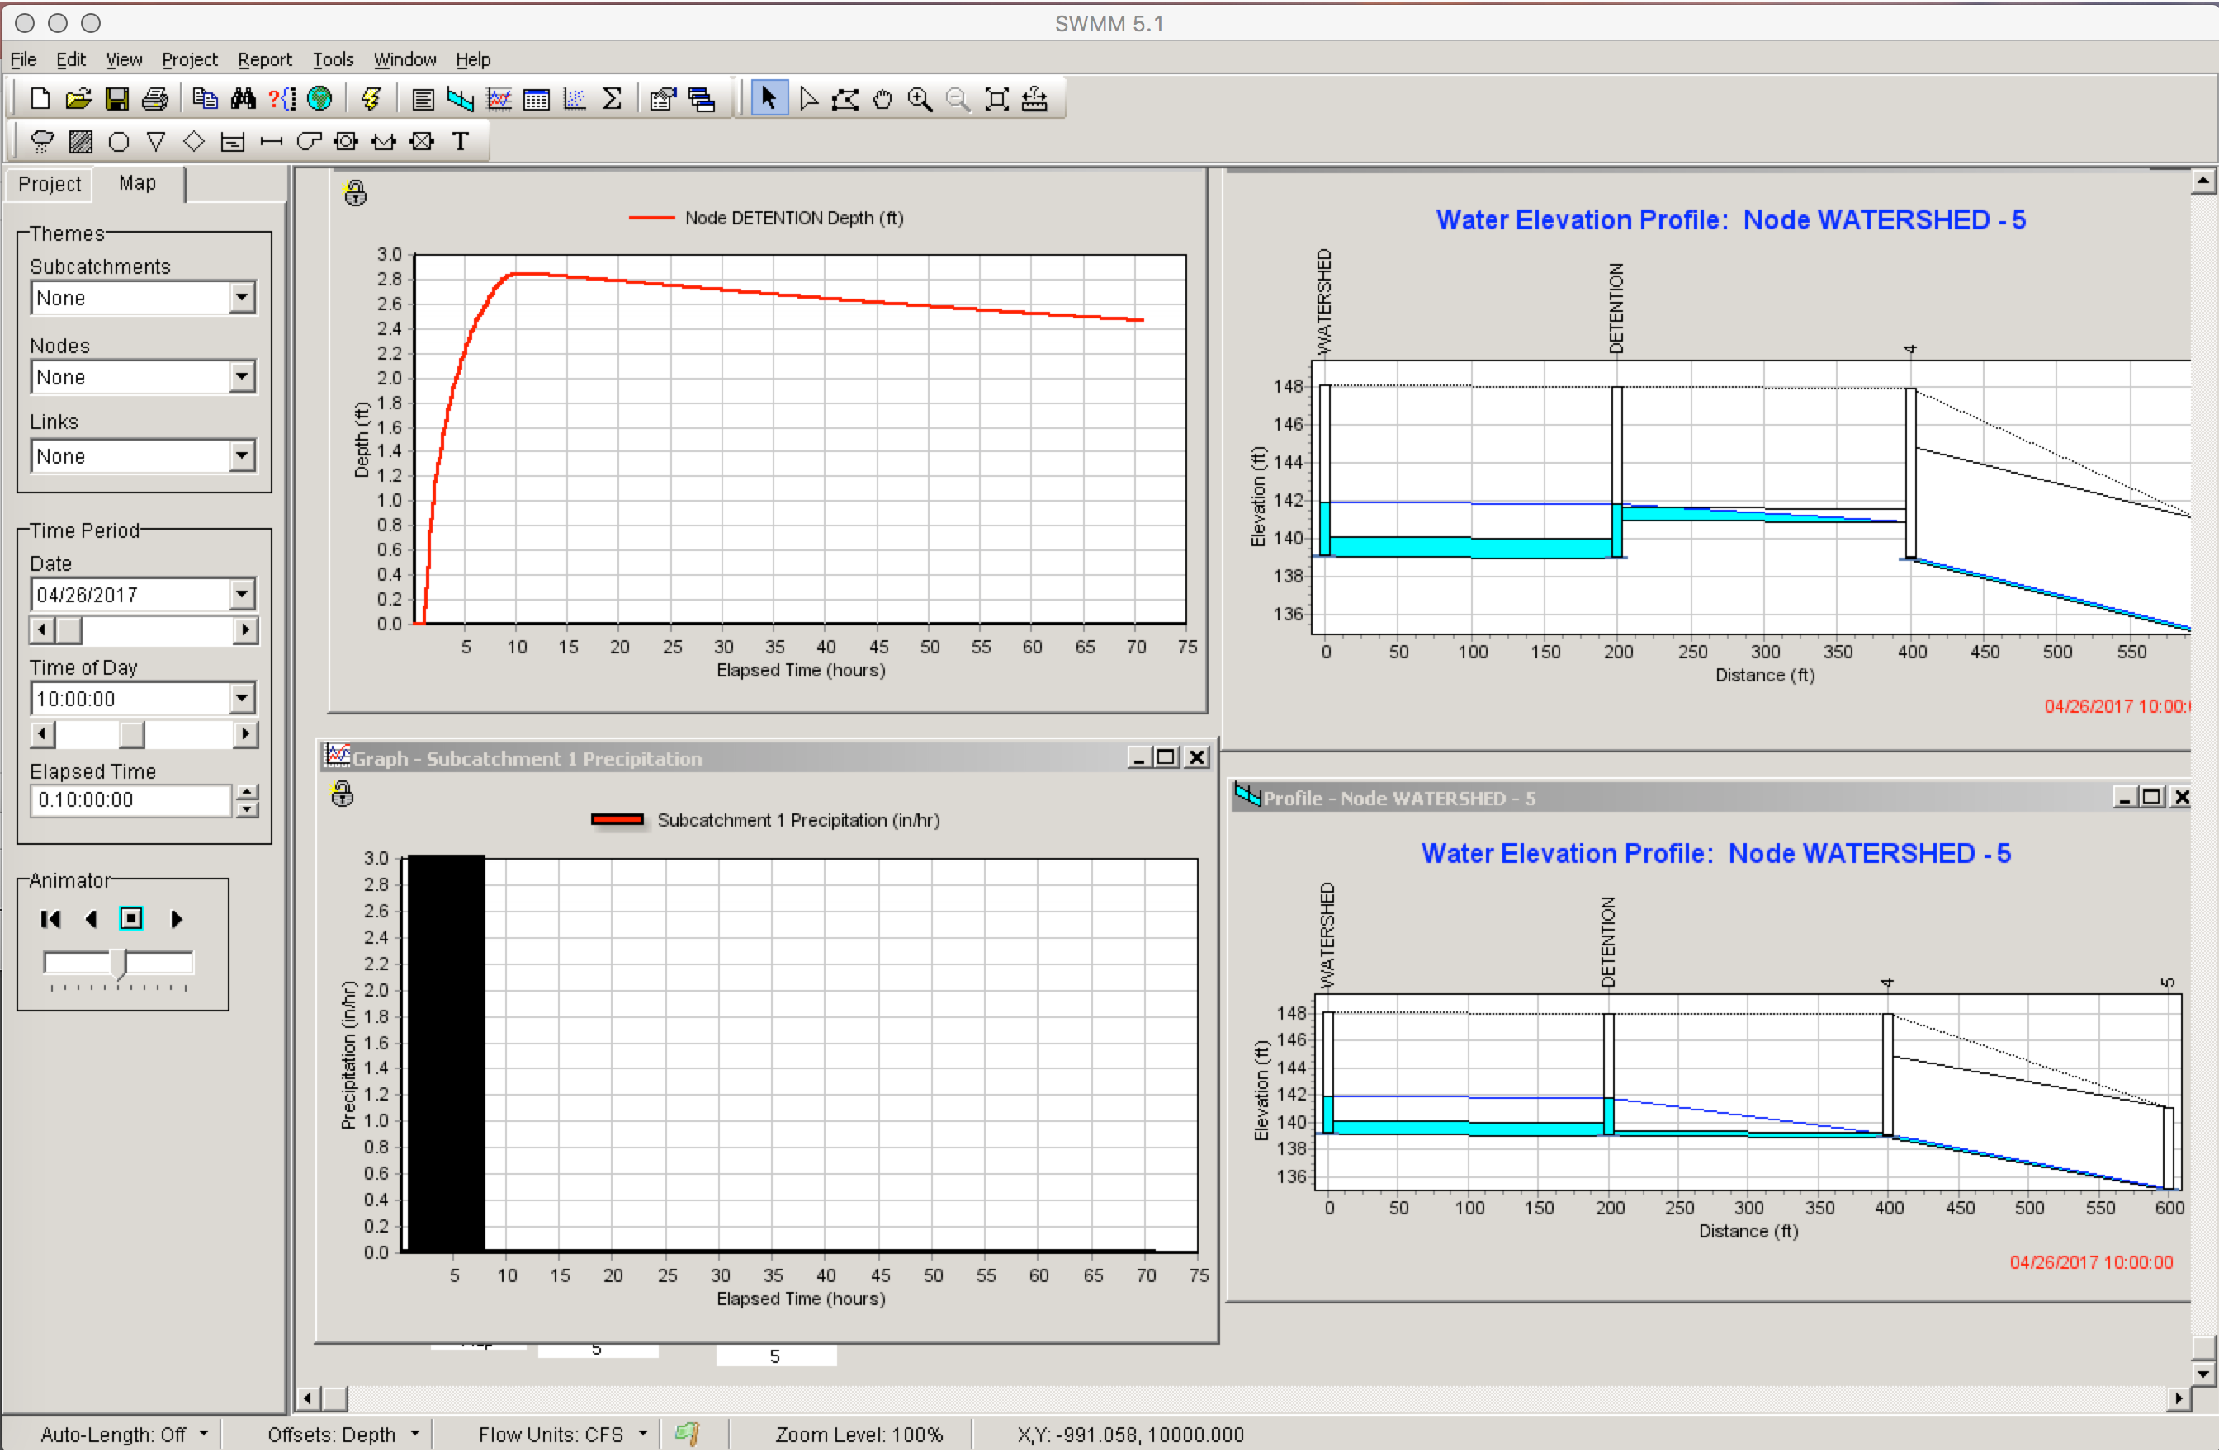

Figure . SWMM Model Graphical Results

1. SWMM Model Graphical Results (Inlet pipe increased in diameter, and slope on inlet side to pond increased) Overflow spillway not activated. Pond still un-drained at 72 hours.

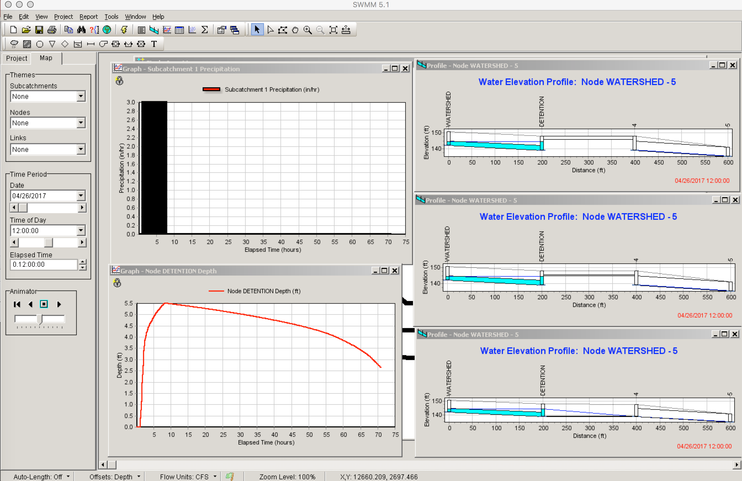

Figure . SWMM Model Graphical Results